1. kubectl apply -f <https://raw.githubusercontent.com/kubernetes/dashboard/v2.7.0/aio/deploy/recommended.yaml>
2. kubectl edit svc kubernetes-dashboard -n kubernetes-dashboard
3. kubectl get svc kubernetes-dashboard -n kubernetes-dashboard
4. kubectl create serviceaccount admin-user -n kubernetes-dashboard
5. kubectl get serviceaccount -n kubernetes-dashboard
6. kubectl -n kubernetes-dashboard create token admin-user

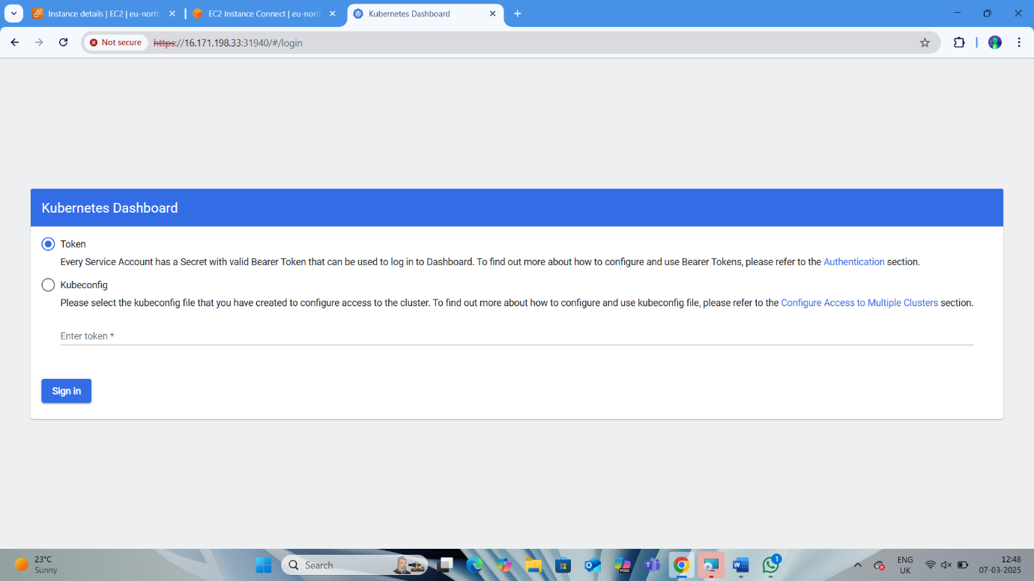

1. 